RTLB LSF Project: Post Intervention Summary
Name, Date and Time frame of project: | Basic fact fluency :Term 2, 2016.  Daily 20 minute basic fact practice and games with a teacher for 10 weeks
Description and breakdown of students involved: | 5 female/5 male students. 6 students in year 6, 4 in year 5.  2 NZ Maori, 8 NZ European
LSF Project description: | Aim of this group is to build basic fact recall with confidence so the students can use this to improve their overall achievement level. Students would be supported in 2 smaller groups by the teacher aid to drill oral basic facts, participate in games to build recall such as numbers up (CD based computer game)and other resources to support the students. The teacher will also be focusing on developing these skills during daily math sessions.Sessions normally started with a warm up such as the flash cards, followed by a written activity or timed basic facts testing and then a relevant game.
Resources involved: | Basic fact sheets, Numbers up, Flash cards, Trifecta, Matchletics
Summary of Pre intervention data: | 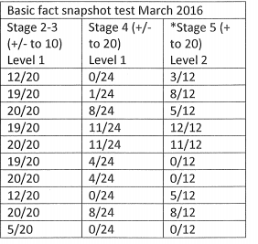
Summary of Post Intervention data: | 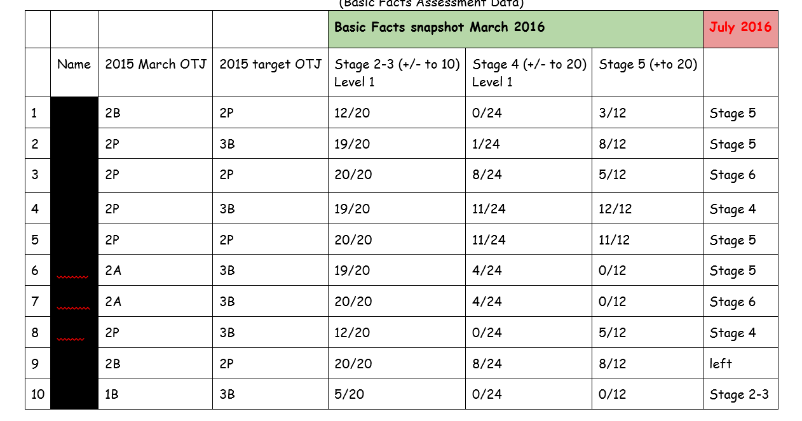
Summary of positive gains: | 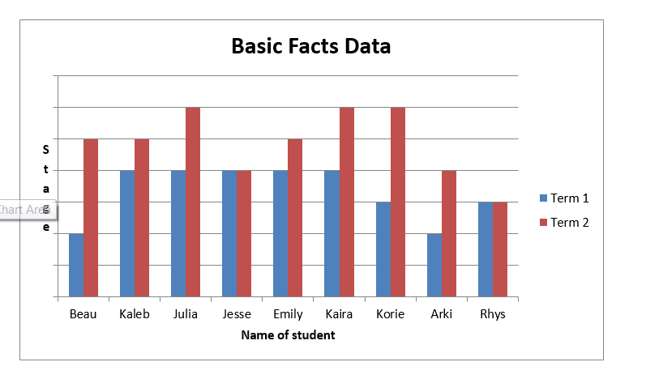
Teacher voice: | Initially we concentrated on addition and subtraction basic facts under 20 and talked about the fact families and patterns in Maths.  Later in the term we moved on to doubling and halving and then included simple multiplication and division.  Some children initially thought the subtraction card game was the most fun and that new games like Trifacta and Matchletics were too difficult. One student was in fact unwilling to give them a go but as confidence grew they all participated and enjoyed these games. Some students continued to use concrete materials to work out basic facts but in my opinion most students gained confidence in basic facts, got faster and more accurate. I am not sure if it was a good idea to have one particular student in the group as he may have slowed down the others and it may have been more beneficial for him to have worked independently on less challenging Maths work.  I thought the Maths games purchased by the school were excellent as they reinforced the basic facts learning really well in an enjoyable way. I think the RTLB funded basic facts maths groups worked quite well last term.
Student voice: | Comments from the students  “The maths groups were helpful. I liked playing the maths games and flash cards. “  “I liked playing games – subtraction you know. The group work made me go faster”  “ The thing that was helpful was that the cards would help us solve harder questions and Marion helped because when we were stuck on a question she would make up a fun way to do it. I didn’t hate it one bit”  “It was fun. The games were cool, my favourite game was trifecta and the card game. I think it made me a lot better at math because we did all the basic facts”  “I got better at basic facts because I kept trying”  “I got better at maths because it started getting easier for me as we kept doing it”  “What worked for me was that it helped me move up a group and tri-facta and matchmatics was very fun”  “I liked that I learned that I could do my maths fast and easy. It was fun and now I have . learnt new strategies
Comments: | We have noticed the students feel more confident and are transferring the improvement into their daily classwork.

